**REACT JS**

**REACT CRASH COURSE**

<https://www.youtube.com/watch?v=jLS0TkAHvRg&t=573s>

**JSON API** - <https://jsonplaceholder.typicode.com/guide/>

**FUNCTIONAL COMPONENTS**

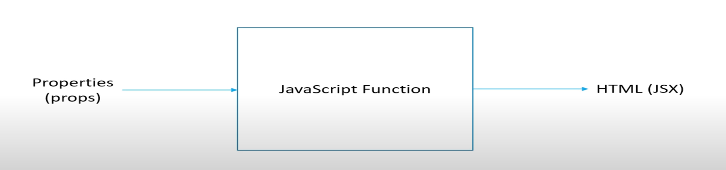

**JSX**

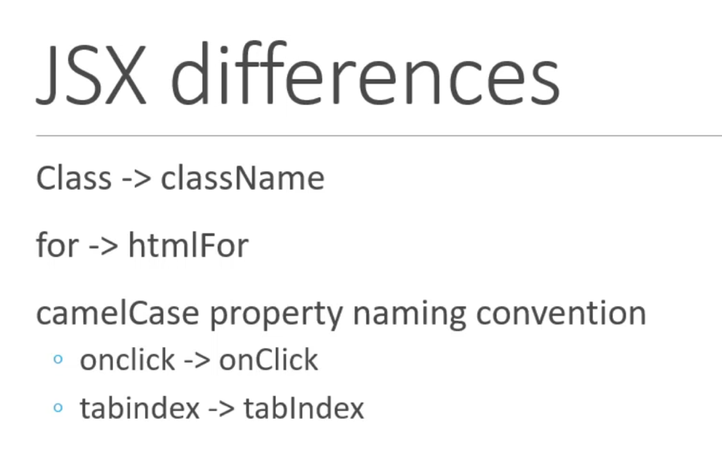

**Named vs Default Export**

Named Export

export const Greet = (props) => <h1>{props.name}</h1>

import {Greet} from './components/Greet';

Default Export

const Greet = (props) => <h1>{props.name}</h1>

export default Greet;

import Greet from './components/Greet';

**Props**

Props are known as properties it can be used to pass data from one component to another.

Props is immutable. The value cannot be changed.

If we know what to pass -> use props.name

If we don’t know what to pass -> pass as props.children using react fragments

**PROPS VS STATE**

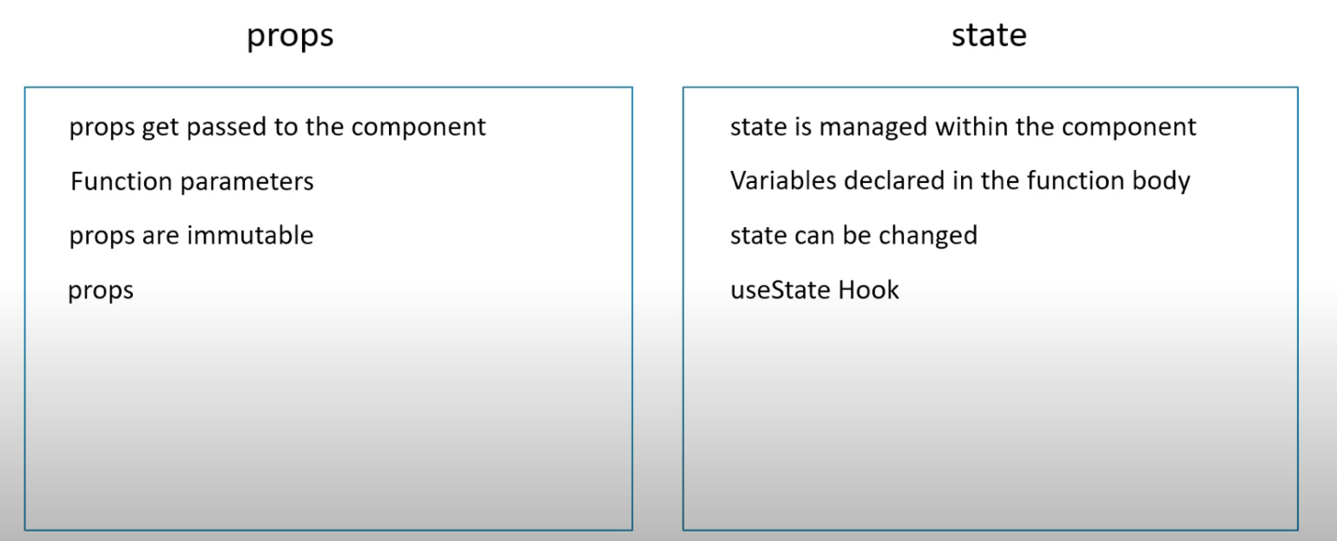

**HOOKS**

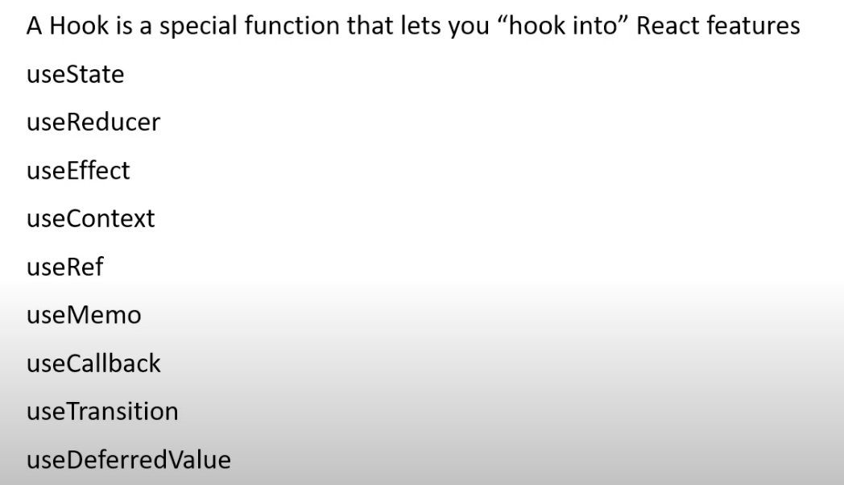

**STYLING REACT COMPONENTS**